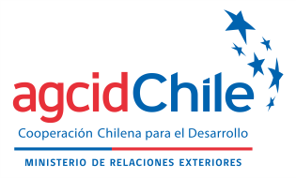

ANNEX III
APPLICANT LETTER OF COMMITMENT
South – South Cooperation Scholarship Program
AGCID - University of Chile

As an applicant for the VII Diploma in Public Management, to be carried out by the University of Chile:
I_________________________________________________________________

Name of the applicant

FROM____________________________________________________________

Country of origin

I declare that all the information presented is true, correct and complete and in case of obtaining the scholarship, I promise to respect the following rules:
- Rigorously comply with the Diploma Program.
- Accept all the conditions stipulated in relation to the Diploma.
- Respect the instructions given during the diploma.
- Do not interrupt the Diploma except in the case of a serious illness that determines the inability to continue the training.
- Carry out knowledge transfer activities and implement my project at the end of the academic program for the completion of the Diploma.
- In case of desisting from participating in the Diploma, once selected, notify the AGCID Point of Contact at least 5 days before the start of the Course and indicate the reasons of force majeure that oblige that decision.

At_________________, on ______________ _________ , _______.
(Place) (Month) (Day) (Year)

Signature of the applicant

